FINAL REPORT

ON

"COMPREHENSIVE ANALYSIS OF CHICAGO CRIME DATA"

DATA 690 STATISTICAL ANALYSIS & VISUALIZATION WITH PYTHON

HARI KIRAN PALLEPATI

PAVAN KUAMR BODDU

LOKESH CHAVA

M.P.S DATA SCIENCE

UNIVERSITY OF MARYLAND, BALTIMORE COUNTY

DECEMBER 15, 2023

# **INTRODUCTION**

Chicago, a city celebrated for its cultural richness and economic dynamism, grapples with a complex challenge: a pervasive concern regarding its crime landscape. With a population exceeding 2.7 million, the city faces a complex interplay of socio-economic factors entangled with varying forms of criminal activities [1].

**Purpose and Overview**

This report delves into an in-depth analysis of the Chicago Crimes dataset, a comprehensive collection of crime records from the city of Chicago, spanning from 2001 to the present. This dataset, sourced from the Chicago Police Department, provides a detailed account of various crime types, locations, and times of occurrence, offering a rich resource for examining the city's crime landscape. The analysis aims to extract significant patterns and trends in criminal activities, thereby enhancing the understanding of crime dynamics in Chicago. With its extensive range of data, the analysis not only presents a snapshot of current crime situations but also provides an opportunity to observe the evolution of crime over the years, paving the way for informed decision-making and policy development.

**Business Objective**

The primary objective of this analysis is to leverage data science and predictive modeling to forecast crime types in Chicago, assisting the Chicago Police Department in preemptive and strategic planning. By accurately predicting potential crime hotspots and trends, the project seeks to enable more effective allocation of police resources and proactive crime prevention measures. This predictive insight is crucial for enhancing public safety, as it helps in deploying law enforcement efforts where they are most needed. The analysis also aims to identify specific patterns in crime occurrences, aiding the police department in tailoring their responses to the unique challenges of different areas and times, thereby optimizing their operational efficiency and impact.

# **DATA**

This dataset contains reported crime incidents (excluding murders where victim data is available) that occurred in Chicago from 2001 to the present, excluding the last seven days. To safeguard victim privacy, addresses are presented at the block level without specific locations. The data comprises unverified reports received by the Police Department. Initial crime classifications might change after further investigation, and errors—both mechanical and human—can occur. Therefore, the Chicago Police Department doesn't assure the accuracy, completeness, timeliness, or exact sequence of this information. It's not recommended for making comparisons over time [2].

Dataset contains 100k records and 30 columns. Among the crucial columns, the 'Primary Type' variable stands as a fundamental descriptor, categorizing various types of reported crimes, ranging from theft and assault to homicide and narcotics-related offenses. Complementing this, the 'Location Description' field delineates where these incidents occurred, detailing whether they took place on the street, in residences, or in other specific settings. Additionally, the 'Arrest' column indicates whether arrests were made in connection with reported crimes, providing a metric to gauge law enforcement responses. Geographical details, encompassed by 'Latitude' and 'Longitude' coordinates, enable spatial mapping of incidents, aiding in pinpointing crime hotspots or trends across Chicago's neighborhoods. Moreover, the 'Date' column allows temporal analysis, unveiling trends over time, while 'District' and 'Community Area' fields provide granular information about the specific police districts and community regions where incidents transpired. These columns collectively offer a comprehensive foundation for detailed analyses, empowering researchers to dissect crime patterns, assess arrest rates, and discern temporal and spatial trends critical for law enforcement strategies and policy interventions in addressing Chicago's crime landscape.

# **DATA PREPARATION AND CLEANING**

**Data Importing**

The initial phase of our analysis involved the meticulous process of importing the Chicago Crimes dataset into our analytical environment, a task critical for the foundation of our entire analysis. Utilizing the Python programming language, renowned for its prowess in data manipulation and analysis, we employed the powerful Pandas library, a cornerstone tool for data scientists. Pandas offers exceptional functionalities for handling large datasets, making it an ideal choice for our purpose. The dataset, sourced from the Chicago Police Department's CLEAR system, was substantial in size, encompassing detailed records of crime incidents stretching over two decades.

Our importing process began with the execution of a script designed to read the data file. The data, stored in a CSV format, was meticulously read into a Pandas Data Frame. This Data Frame structure is particularly advantageous for handling large datasets due to its efficient design and ease of manipulation. Throughout this phase, we were cautious to maintain the integrity of the data, ensuring that every record was accurately represented in our analytical environment. This step set the stage for our subsequent exploratory and analytical processes, providing us with a robust and reliable dataset to work upon.

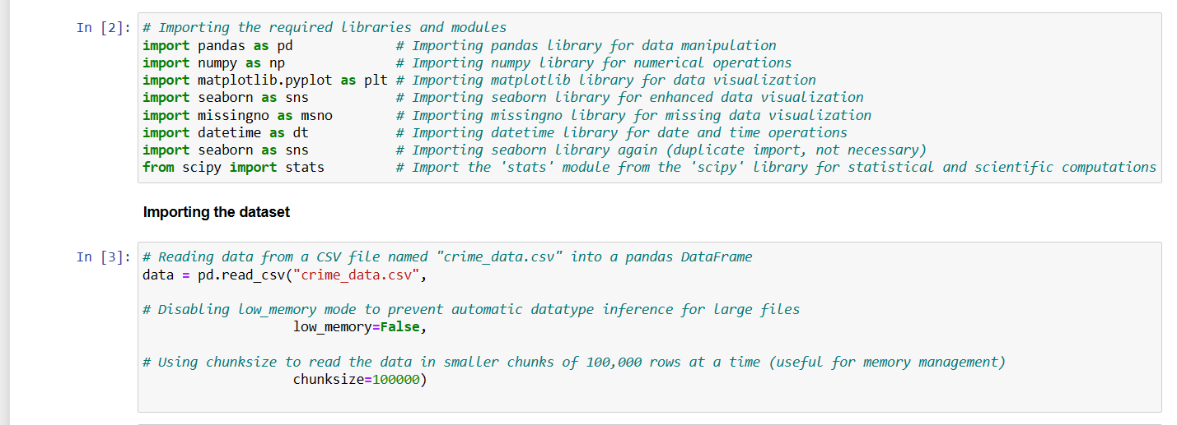

Below image provides details about the Data Frame, including column names, data types, and memory usage.

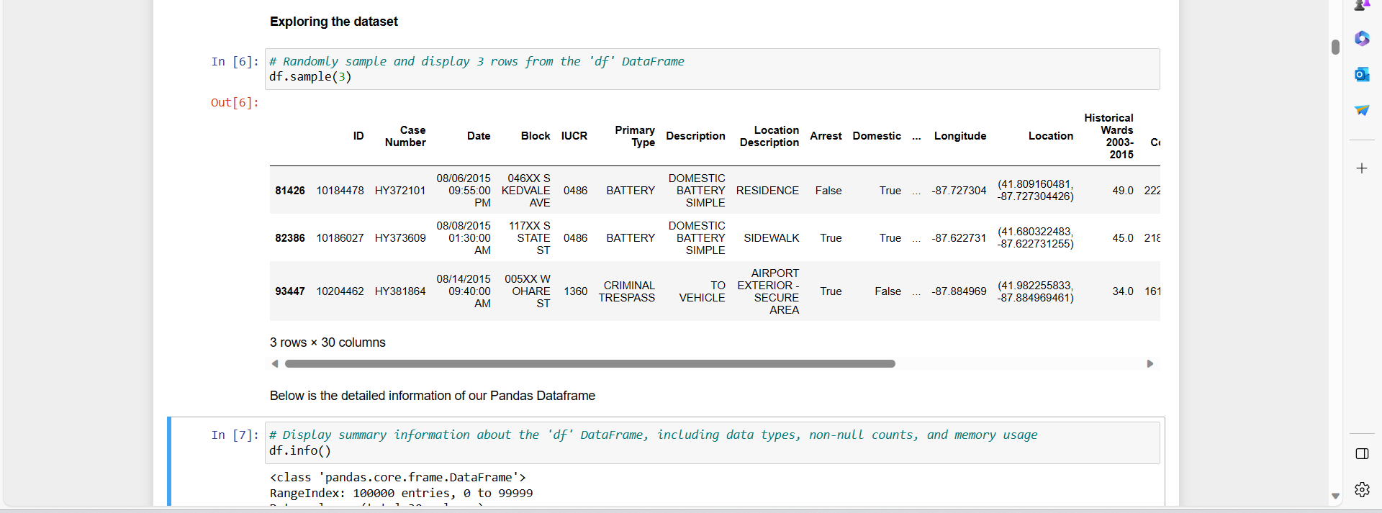

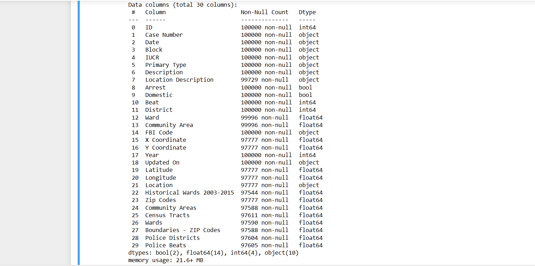

Below is a summary of statistical information per column of the dataset.

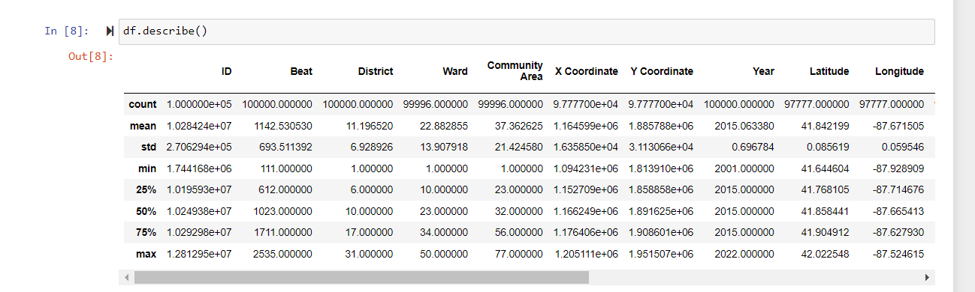

**Data Cleaning Process**

Once the data was successfully imported, our focus shifted to the critical task of data cleaning and preprocessing, a stage that significantly influences the accuracy and reliability of any data analysis. Given the vastness and complexity of the Chicago Crimes dataset, this phase was both challenging and crucial. Our initial assessment revealed several issues typical of large datasets: missing values, inconsistencies in data formats, and the presence of irrelevant columns that could potentially skew our analysis.

To address these challenges, we embarked on a systematic cleaning process.

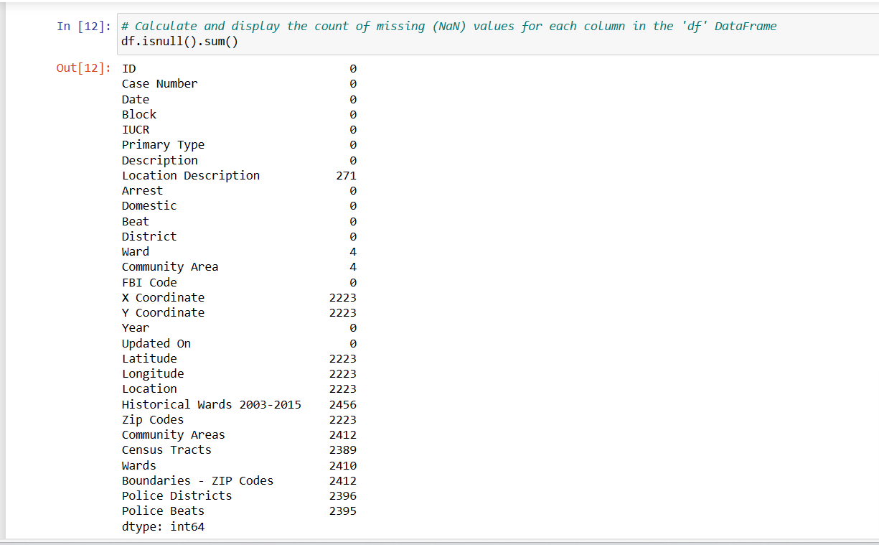

Firstly, we tackled the missing values, a common issue in real-world datasets. Decisions regarding whether to fill these gaps with plausible values or to remove the affected records entirely were made based on the nature and significance of each column. Additionally, we ensured that all data types were correctly identified and consistent across the dataset, an essential step for accurate computational analysis. Another significant aspect of our cleaning process was the filtering and removal of irrelevant columns. This step not only streamlined the dataset for a more focused analysis but also contributed to more efficient processing and reduced computational load.

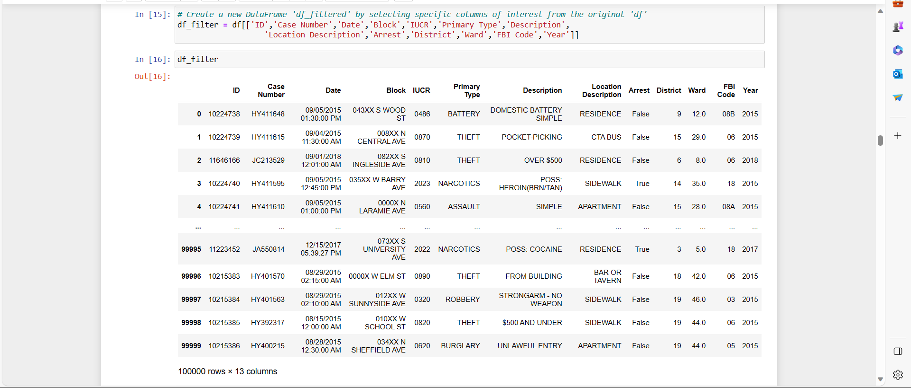

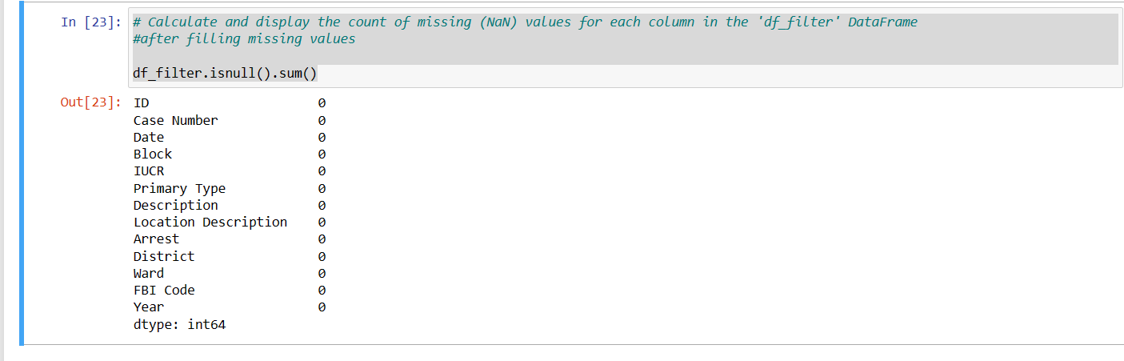

# **VISUALIZATIONS**

Throughout the notebook, a range of visualizations was employed to convey the complexities and nuances of the crime data in a more accessible and interpretable manner. These visualizations included various formats such as bar graphs, histograms, each offering unique insights into the dataset. For instance, bar graphs might have been used to illustrate the distribution of different types of crimes. These visual tools are invaluable for identifying patterns and trends that might not be immediately apparent from raw data, offering a visual narrative of crime dynamics in Chicago.

* Below plot shows the number of occurrences against each type of crime. We can conclude from the below image that “THEFT” has more numbers than any other with count of 22301.

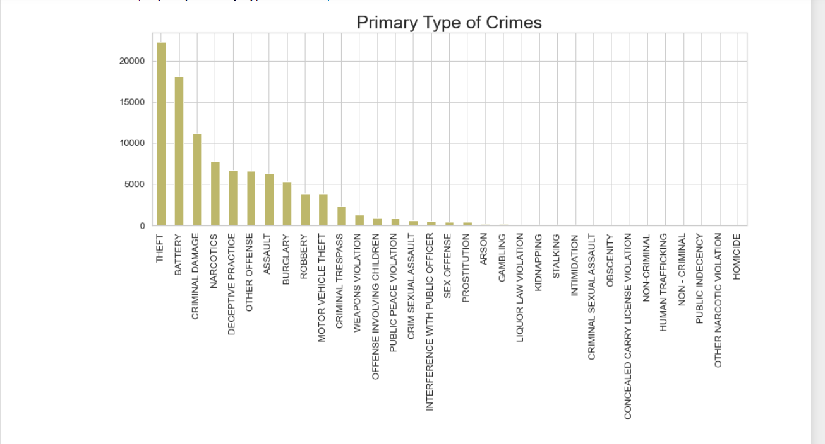

* From below Image we have concluded top 10 “Crimes Description” from the total crime description. The description “$500 AND UNDER” occupies first position compared to the other descriptions.

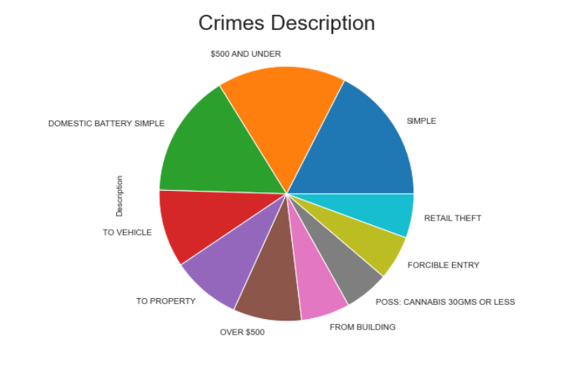

* Below graph illustrates a significant occurrence of crimes, particularly theft and domestic battery, predominantly taking place on streets. This pattern indicates that one of the prevalent ways these crimes occur is through theft from parked vehicles on the streets.

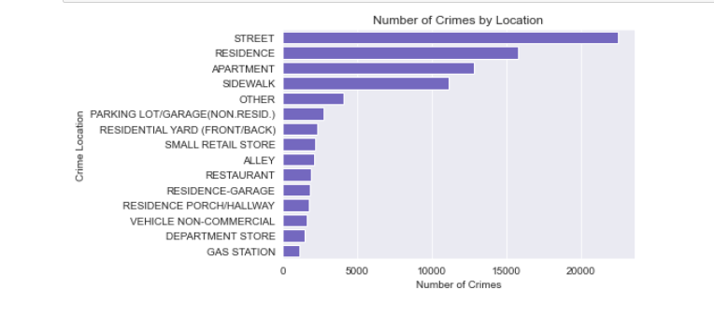

* October emerges as the month with the highest incidence of crimes, surpassing all other months in frequency and occurrence based on the dataset analysis.

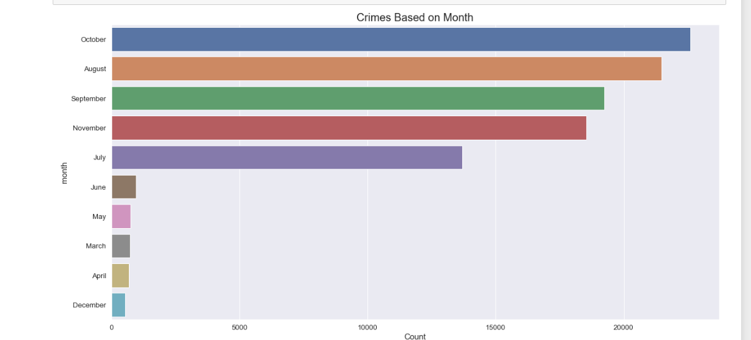

* The data depicts varying crime trends throughout the week, suggesting potential correlations between certain types of crimes and specific days. These trends might highlight higher incidences of offenses on weekends versus weekdays.

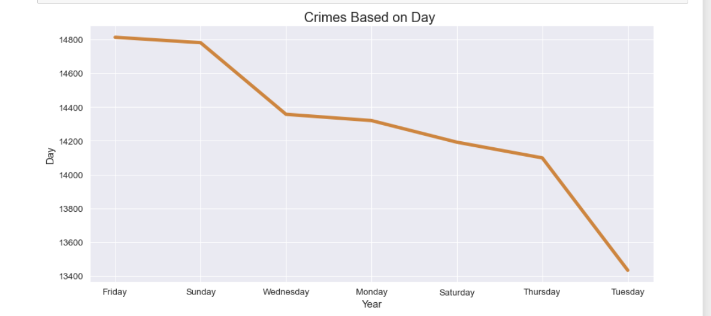

* True represents the arrest and it is quite evident that there is very less arrest for the crimes that have been happening in Chicago

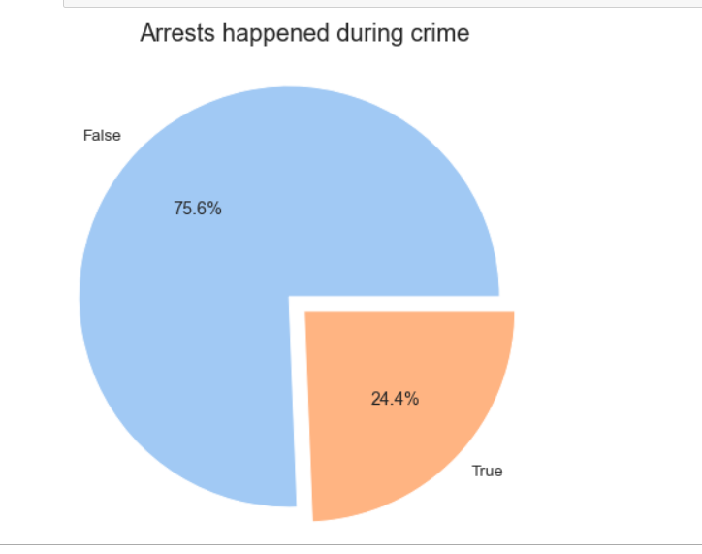

* The histogram's bars show the frequency of crime occurrences in each police district, while the smooth line of the kernel density estimate provides a continuous probability density of the data. The peaks in the plot suggest districts with higher crime occurrences, whereas valleys indicate districts with fewer reported crimes, offering a clear visual representation of how crime incidents are distributed across the different districts in Chicago.

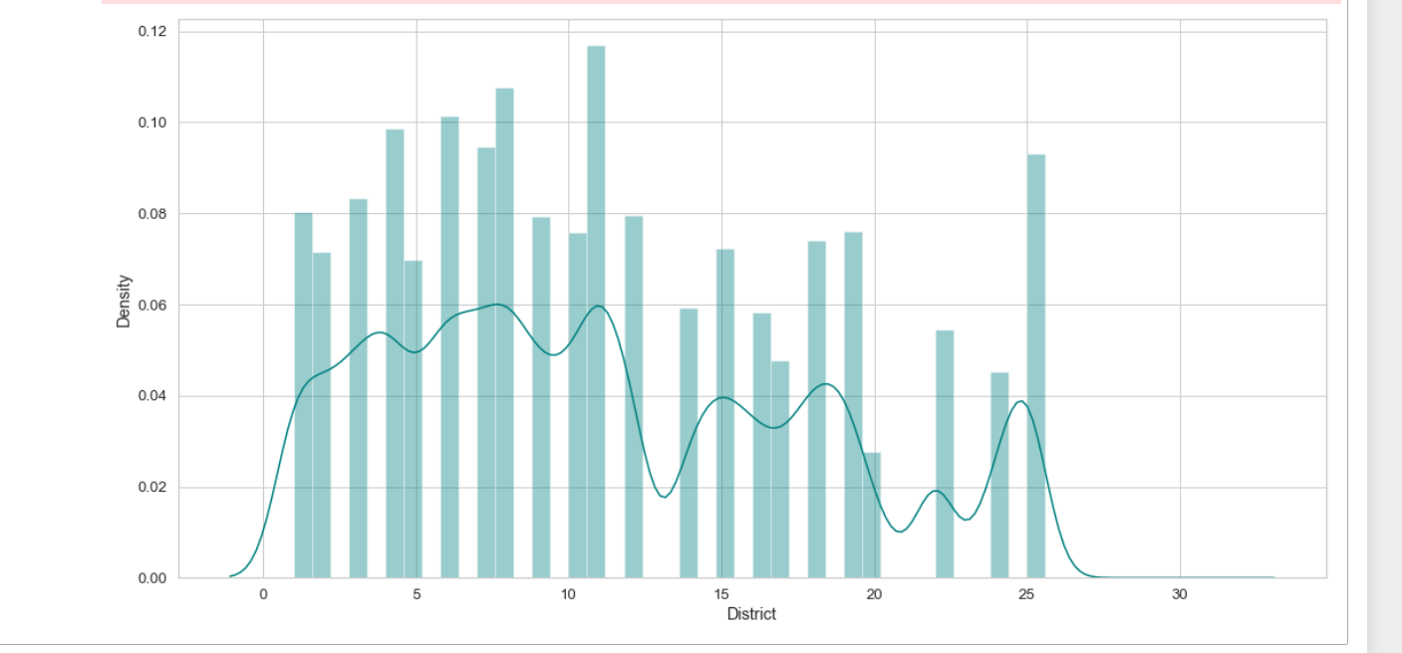

# **HYPOTHESIS TESTING**

Hypothesis testing is a statistical method used to determine the validity of a hypothesis about a population parameter. It involves formulating a null hypothesis and an alternative hypothesis, then using sample data to assess the likelihood of the null hypothesis being true. In our rigorous analysis of the Chicago Crimes dataset, we employed hypothesis testing as a fundamental method to validate assumptions and uncover deeper insights into crime patterns in Chicago. This scientific approach allowed us to statistically assess the validity of specific hypotheses, thereby transforming raw data into meaningful information. Our focus was on testing a series of hypotheses related to different aspects of criminal activities, including seasonal variations in crime rates, comparisons between different types of crimes, and the examination of arrest rates across various districts and years.

By applying these statistical tests, we aimed to understand whether certain perceived patterns held true under statistical scrutiny, such as the potential increase in burglary rates during winter months, differences in arrest rates between theft and battery crimes, fluctuations in narcotics-related arrest rates in recent years, and variations in robbery arrest rates across different districts. These hypotheses were meticulously crafted to probe into the nuanced dynamics of crime in Chicago, providing a data-driven foundation to support or refute common perceptions and inform effective law enforcement strategies.

**Burglary Rates in Winter Months**

The first hypothesis tested was whether the arrest rate for burglaries during winter months (December, January, February) is significantly higher than in other months. The analysis involved categorizing the burglary data into winter and non-winter groups and performing a one-tail t-test. The results yielded a T-statistic of -17.54 and a P-value of approximately 2.49e-67, indicating sufficient evidence to reject the null hypothesis at the 0.05 level. This suggests that the arrest rate for burglaries is significantly higher during winter months compared to other months.

**Comparison of Arrest Rates for Theft and Battery Crimes**

The second hypothesis aimed to determine if there was a significant difference in the arrest rates between theft and battery crimes. The analysis involved performing a two-tail t-test on the arrest data for both crime types. The test resulted in a T-statistic of -31.25 and a P-value of approximately 3.10e-211, which provided sufficient evidence to reject the null hypothesis at the 0.05 level. This outcome suggests that there is a significant difference in the arrest rates between theft and battery crimes, highlighting distinct patterns in law enforcement responses to these crime types.

**Narcotics-Related Arrest Rates in 2020 Compared to Previous Years**

The third hypothesis focused on whether the average arrest rate for narcotics-related crimes in 2020 was significantly higher than in previous years. The analysis calculated arrest rates for 2020 and prior years and performed a Z-test. The Z-score was 0.0883, and the P-value was 0.4648, indicating that there was not enough evidence to reject the null hypothesis. Consequently, it could not be concluded that the arrest rate for narcotics-related crimes in 2020 was higher than in previous years, suggesting a consistency in narcotics-related arrests over the analyzed time period.

**Arrest Rate for Robbery Crimes in District 5**

The final hypothesis tested whether the arrest rate for robbery crimes in District 5 was significantly different from the city-wide average. The analysis involved calculating the average arrest rates for District 5 and city-wide, followed by a Z-test. The Z-score was -9.18 with a P-value of approximately 4.13e-20, providing strong evidence to reject the null hypothesis. This indicates that the arrest rate for robbery crimes in District 5 is significantly different from the city-wide average, pointing towards unique crime dynamics or law enforcement effectiveness in that district.

# **CONCLUSIONS**

The comprehensive analysis carried out has led to several key conclusions that enhance our understanding of crime in Chicago. The findings suggest that theft is the most prevalent crime, followed by battery, criminal damage, and narcotics-related offenses. This highlights the areas where law enforcement and community programs may need to focus their efforts. The distribution of these crimes across different districts also provides insight into the spatial dynamics of criminal activity, which could be pivotal for resource allocation and preventive measures.

The visualizations have underscored distinct trends, such as the concentration of certain crimes in specific districts or times of the year. These graphical representations serve as a powerful tool for quickly identifying patterns that may require further investigation or immediate action.

The hypothesis tests conducted provide a statistically rigorous backdrop to the observational trends. Notably, the arrest rates for burglary during winter months are significantly higher than in other seasons, which could indicate either seasonal fluctuations in crime rates or a seasonal efficacy in police activity. However, the analysis could not confirm a significant increase in narcotics-related arrests in 2020 compared to previous years, suggesting a consistency in narcotics-related arrests over time. In District 5, the arrest rate for robbery crimes is significantly different from the city-wide average, which could point to unique local factors affecting crime or the effectiveness of policing strategies in that district.

These conclusions offer valuable insights for policymakers and law enforcement, providing a data-driven basis for strategic decisions aimed at crime prevention and control. They also open avenues for further research, particularly in understanding the reasons behind these patterns and the effectiveness of current strategies to mitigate crime in Chicago. ​

# **DISCUSSION**

During the course of this analysis, several limitations were encountered that should be acknowledged to provide a more accurate interpretation of the findings. Firstly, the dataset used for this study, sourced from the City of Chicago's Crime Data portal, may have inherent biases. The data relies on reported crimes, and underreporting is a common issue in crime statistics, potentially leading to an incomplete and skewed representation of the true crime landscape. Additionally, the dataset lacks granular details such as socio-economic factors, which are crucial in understanding the root causes of crime. Without a comprehensive socio-economic context, it becomes challenging to formulate holistic strategies for crime prevention and control. This limitation underscores the need for supplementary data sources and interdisciplinary collaboration to develop a more nuanced understanding of crime dynamics.

The absence of certain details also affects the generalizability of the conclusions. For instance, the analysis focused on arrest rates and crime categories but did not delve into demographic details of the individuals involved, potentially missing patterns related to age, gender, or socio-economic background. A more comprehensive dataset could enable a more nuanced exploration of these factors and their correlations with different types of crimes. Recognizing and addressing these limitations is crucial for policymakers and law enforcement to make informed decisions while understanding that the findings presented are based on the available data and may not capture the full complexity of the crime landscape in Chicago.

# **REFERENCES:**

*City of Chicago Crime Data | City of Chicago | Data Portal*. (n.d.). Chicago. <https://data.cityofchicago.org/Public-Safety/City-of-Chicago-Crime-Data/v9q9-3dm2>

**APPENDIX**